**Requirements Specification**

**Version 1.0**

June 04**, 202**3

**Table of Contents**

**1. Executive Summary 2**

**1.1 Project Overview 3**

**1.2 Purpose and Scope of this Specification 3**

**2. Product/Service Description 4**

**2.1 Product Context 4**

**2.2 User Characteristics 5**

**2.3 Assumptions 6**

**2.4 Constraints 6**

**2.5 Dependencies 7**

**3. Requirements 7**

**3.1 Functional Requirements 8**

3.2 Non-Functional Requirements 11

**3.2.1 Product Requirements 11**

**3.2.1.1 User Interface Requirements 11**

**3.2.1.2 Usability 12**

3.2.1.3 Efficiency 13

**3.2.1.3.1 Performance Requirements 13**

**3.2.1.3.2 Space Requirements 13**

**3.2.1.4 Dependability 13**

**3.2.1.5 Security 14**

**3.2.2 Organizational Requirements 15**

**3.2.2.1 Environmental Requirements 15**

**3.2.2.2 Operational Requirements 15**

**3.2.2.3 Development Requirements 16**

3.2.3 External Requirements 17

**3.2.3.1 Regulatory Requirements 17**

**3.2.3.2 Ethical Requirements 17**

**3.2.3.3 Legislative Requirements 18**

**3.2.3.3.1 Accounting Requirements 18**

3.2.3.3.2 Security Requirements 19

3.3 Domain Requirements 20

**4. User Scenarios/Use Cases 21**

4.1 Use Case Diagrams 21

4.2 Use Cases Extended 25

4.3 BPMN 36

4.4 Data Flow Diagrams 36

4.5 Entity-Relationship Diagram 40

4.6 Activity Diagrams 41

4.7 Sequence Diagram 50

4.8 State Diagrams 56

4.9 Class Diagram 65

# Executive Summary

## ***Project Overview***

The focus of this software will be to create an educational platform that caters to the needs of teachers, parents, and students. The software will be designed as a comprehensive learning management system (LMS) that provides an online platform for managing course content, assignments, and progress tracking.

Teachers will have the ability to upload course material, such as presentations, handouts, and assignments. They will be able to manage course content by organizing it based on subject, topic, and difficulty level. Teachers can also create and manage assessments, such as quizzes and exams, and track student progress and grades. Communication with students and parents will be facilitated through the platform's messaging system.

Parents will be able to monitor their child's academic performance and progress, view their child's grades, assignments, and progress reports, communicate with teachers through the platform's messaging system, and receive alerts and notifications regarding their child's performance or upcoming deadlines.

Students will be able to access course material, including presentations, handouts, and assignments, complete and submit assignments and assessments, track their own academic performance and progress, and communicate with teachers through the platform's messaging system.

The platform will be accessible through a web browser and will include mobile applications for Android and iOS devices. The application will have a three-level user system: Teacher, Parent, and Student. Each user will have different views and functionalities based on their roles.

The software will be designed to create a user-friendly, comprehensive, and scalable platform that will streamline the educational experience for everyone involved. Teachers will be able to easily upload and manage course material, while students will be able to access and complete assignments and exams from a single location. Parents will be able to monitor their children's progress and communicate with teachers to stay informed about their child's academic performance. Overall, the aim of the educational platform is to create a centralized location for managing coursework, assignments, and progress tracking, providing an enhanced learning experience for all users involved.

## ***Purpose and Scope of this Specification***

The purpose of this software specification is to define the requirements and functionalities of an educational platform that serves as a learning management system for teachers, students, and parents. The intended audience for this specification includes software developers, project managers, and stakeholders involved in the design, development, and implementation of the platform.

In Scope:

* The platform must allow teachers to create and manage courses, upload and organize course content, set assignments, and monitor student progress.
* The platform should enable students to access course materials, complete assignments, and receive feedback from teachers.
* The platform must provide a dashboard for parents to monitor their children's progress, view grades and assignments, and communicate with teachers.
* The platform should offer features such as a calendar, notifications, and messaging to facilitate communication between teachers, students, and parents.
* The platform must ensure the security of data, such as student records and personal information.
* The platform should support various types of multimedia content, such as videos and images, for a rich learning experience.

Out of Scope:

* The platform will not provide any hardware or software for users to access the system.
* The platform will not provide any direct teaching or educational content.
* The platform will not include any features or functionalities that violate any laws or regulations.

# **Product/Service Description**

In this section, describe the general factors that affect the product and its requirements. This section should contain background information, not state specific requirements (provide the reasons why certain specific requirements are later specified).

## ***Product Context***

In today's world, education has become more important than ever. With the rapid pace of technological advancement, it is necessary for people to continuously update their skills and knowledge to stay competitive in the job market. However, traditional education systems are often not able to keep up with these changes, leaving many people struggling to find ways to access the information they need to succeed.

This is where an education platform comes in. An education platform is an online platform that provides access to a wide range of educational resources, including courses, tutorials, and other learning materials. The platform can be accessed from anywhere in the world, at any time, making it easy for people to fit learning into their busy lives.

The platform is designed to be user-friendly and intuitive, making it easy for people of all ages and backgrounds to use. It features a variety of tools and resources to help learners succeed, including interactive quizzes, discussion forums, and personalized learning plans.

One of the key advantages of an education platform is that it can be customized to meet the needs of different types of learners. For example, some people may prefer to learn at their own pace, while others may prefer a more structured approach. The platform can accommodate both types of learners, providing a personalized learning experience that is tailored to their individual needs.

Overall, an education platform is a powerful tool for anyone looking to enhance their skills and knowledge. Whether you are a student, a working professional, or simply someone who wants to learn something new, an education platform can provide the resources and support you need to achieve your goals.

## ***User Characteristics***

*Teacher:*

Age range: 25-65 years old

Education level: Tertiary

Experience: Extensive experience in teaching, may have used various online learning platforms in the past

Technical expertise: Proficient in using computers and technology, may have expertise in using various educational software

Characteristics: May have different teaching styles and preferences, may have varying levels of comfort with technology, may have limited time for managing the platform due to teaching and administrative responsibilities.

The teacher is the primary user of the platform and has various responsibilities such as creating and managing courses, uploading and organizing course content, setting assignments, monitoring student progress, and communicating with students and parents. The teacher is expected to be proficient in using the platform and must be able to troubleshoot any issues that arise. The teacher may have different teaching styles and preferences that require customization and flexibility of the platform. The teacher may also have limited time to manage the platform due to their teaching and administrative responsibilities.

*Student:*

Age range: 6-24 years old

Education level: Primary, secondary, tertiary

Experience: May have some experience with online learning platforms but may not be proficient in using technology

Technical expertise: Basic computer skills, familiarity with social media and messaging apps

Characteristics: Diverse backgrounds, learning styles, and interests. May have limited access to technology or internet connectivity. May have varying levels of engagement with the platform.

The student is the primary user of the platform and must be able to access course materials, complete assignments, and receive feedback from teachers. The student's learning styles and interests must be considered when designing the platform to ensure a personalized and engaging learning experience. The student may have varying levels of engagement with the platform, and it is essential to provide features such as gamification, multimedia content, and social interaction to promote engagement. The student may have limited access to technology or internet connectivity, and it is necessary to provide offline access to course materials and assignments.

*Parent/Guardian:*

Age range: 25-65 years old

Education level: Varies

Experience: May have experience using online platforms for personal or professional use

Technical expertise: Basic computer skills, familiarity with social media and messaging apps

Characteristics: May have varying levels of involvement in their children's education. May have limited access to technology or internet connectivity. May have concerns regarding their children's privacy and security. May be interested in tracking their children's progress and communicating with teachers.

The parent is a secondary user of the platform and has a role in monitoring their children's progress, viewing grades and assignments, and communicating with teachers. The parent may have varying levels of involvement in their children's education, and it is necessary to provide features such as progress tracking, notifications, and communication channels to promote their engagement. The parent may have limited access to technology or internet connectivity, and it is essential to provide user-friendly and accessible interfaces to facilitate their use of the platform. The parent may also have concerns regarding their children's privacy and security, and it is necessary to ensure the platform's compliance with relevant regulations and policies.

## ***Assumptions***

Here are some assumptions that may affect the requirements:

* Availability of equipment: It is assumed that all users have access to the necessary equipment to use the platform, including a computer or mobile device and a stable internet connection.
* User expertise: It is assumed that teachers, students, and parents have basic computer skills and are familiar with using online platforms for communication and learning.
* Platform compatibility: It is assumed that the platform is compatible with commonly used web browsers, operating systems, and mobile devices.
* Privacy and security: It is assumed that the platform will comply with relevant privacy and security regulations to protect user data and information.
* Content creation: It is assumed that teachers have the necessary skills and expertise to create and upload course content to the platform.
* Student engagement: It is assumed that students will be motivated and engaged in using the platform, and that the platform will provide features to promote engagement and participation.
* Technical support: It is assumed that technical support will be available to users to address any technical issues that may arise when using the platform.

These assumptions may impact the design and development of the platform, as well as the training and support provided to users. If any of these assumptions are not met, the requirements specification may need to be revised accordingly to ensure that the platform can still meet the needs of its users.

## ***Constraints***

The application must operate in parallel with an old system, there are several items that can constrain design options. Some of these items include:

Compatibility, Capacity, Interference, Maintenance and Cost

By creating the new application with audit functions, such as an audit trail or log files, there are several items that can constrain the design options. Some of these items include:

Storage capacity, Processing power, Data security, Compliance requirements and the User interface

By creating the new application with access, management, and security requirements, there are several items that can constrain the design options. Some of these items include:

Authentication and authorization, Role-based access control, Data privacy and confidentiality, System monitoring and auditing and Compliance requirements

When designing the application for criticality, there are several items that can constrain the design options. Some of these items include:

Redundancy and fault tolerance, Performance, Security, Maintenance and support also Compliance requirements

When designing the application that is subject to resource constraints, there are several items that can constrain the design options. Some of these items include:

Hardware limitations, Scalability, Performance requirements, Cost and the Compatibility with existing infrastructure

When designing the application, there are often additional design constraints that can constrain the design options. Some of these constraints include:

Design standards, Compatibility with existing systems, User interface requirements, Performance requirements, Maintenance and support requirements

## ***Dependencies***

* Students must submit their assignment before the deadline. There is no submission after the required data and time, or else they

will get a 0 for that task.

* There will be no more than 4 course/subject evaluation methods per day. More than this means more workload for students and reciprocally more work for teachers or parents.
* The application is not designed for an unlimited number of students. The capacity of the system holds no more than 20 teachers and 100 students.
* With each student there will also be his/her respective parent/s, so that should not be more than 120.
* The subject will have a limited number of assignments/quizzes/projects/exams that should not exceed 100% altogether.
* To make the communication process between the students and the teachers/parents possible, notifications need to be sent to all these

three to ensure that everything is being notified.

* Teachers need to have a graphical description regarding the child's academic performance/activity progress so that they can make their

assessments more accurately and objectively.

* A forum for the communication between the students is mandatory, so that they can share any difficulties they have about certain questions together.
* A syllabus system is strictly requested too; in this way, the course can be divided into sections, topics, assessment methods, learning objectives, and the weight in percentage for each assessment method.
* Students need to be enrolled by a teacher to be part of a certain course, and the lack of a login system (so that the parents/students/teachers can enter the system) is prohibited.

# Requirements

* Describe all system requirements in enough detail for designers to design a system satisfying the requirements and testers to verify that the system satisfies requirements.
* Organize these requirements in a way that works best for your project. See Appendix DAppendix D, Organizing the Requirements for different ways to organize these requirements.
* Describe every input into the system, every output from the system, and every function performed by the system in response to an input or in support of an output. (Specify what functions are to be performed on what data to produce what results at what location for whom.)
* Each requirement should be numbered (or uniquely identifiable) and prioritized.

See the sample requirements in Functional Requirements, and System Interface/Integration, as well as these example priority definitions:

**Priority Definitions**

The following definitions are intended as a guideline to prioritize requirements.

* Priority 1 – The requirement is a “must have” as outlined by policy/law
* Priority 2 – The requirement is needed for improved processing, and the fulfillment of the requirement will create immediate benefits
* Priority 3 – The requirement is a “nice to have” which may include new functionality

It may be helpful to phrase the requirement in terms of its priority, e.g., "The value of the employee status sent to DIS **must be** either A or I" or "It **would be nice** if the application warned the user that the expiration date was 3 business days away". Another approach would be to group requirements by priority category.

* A good requirement is:
* Correct
* Unambiguous (all statements have exactly one interpretation)
* Complete (where TBDs are absolutely necessary, document why the information is unknown, who is responsible for resolution, and the deadline)
* Consistent
* Ranked for importance and/or stability
* Verifiable (avoid soft descriptions like “works well”, “is user friendly”; use concrete terms and specify measurable quantities)
* Modifiable (evolve the Requirements Specification only via a formal change process, preserving a complete audit trail of changes)
* Does not specify any particular design
* Traceable (cross-reference with source documents and spawned documents).

## ***Functional Requirements***

In the example below, the requirement numbering has a scheme - BR_LR_0## (BR for Business Requirement, LR for Labor Relations). For small projects simply BR-## would suffice. Keep in mind that if no prefix is used, the traceability matrix may be difficult to create (e.g., no differentiation between '02' as a business requirement vs. a test case)

The following table is an example format for requirements. Choose whatever format works best for your project.

For Example:

| **Req#** | **Requirement** | **Comments** | **Priority** | **Date Rvwd** | **SME Reviewed / Approved** |
| --- | --- | --- | --- | --- | --- |
| LMS_BR_01 | The system should allow instructors to create and publish courses. | Business Process = “Course Creation and Publication” | 1 | 21.05.2023 | Omar |
| LMS_BR_02 | The system should provide a dashboard for students to view their progress. | Business Process = “Student Progress Tracking” | 1 | 21.05.2023 | Omar |
| LMS_BR_03 | The system should allow students to view course materials and assignments. | Business Process = “Course Materials and Assignments” | 1 | 21.05.2023 | Omar |
| LMS_BR_04 | The system should allow instructors to grade and provide feedback on student assignments. | Business Process = “Grading and Feedback” | 1 | 21.05.2023 | Omar |
| LMS_BR_05 | The system should provide a discussion forum for students to communicate with each other and with instructors. | Business Process = “Discussion Forum” | 1 | 21.05.2023 | Omar |
| LMS_BR_06 | The system should allow instructors to schedule and conduct virtual classroom sessions. | Business Process = “Virtual Classroom” | 1 | 21.05.2023 | Omar |
| LMS_BR_07 | The system should allow students to upload assignments. | Business Process = “Uploading Assignments” | 1 | 21.05.2023 | Omar |
| LMS_BR_08 | The system should allow instructors to generate reports on student performance. | Business Process = “Reporting” | 1 | 21.05.2023 | Omar |
| LMS_BR_09 | The system should allow administrators to manage user accounts and system settings. | Business Process = “Administration” | 1 | 21.05.2023 | Omar |
| LMS_BR_10 | The application should be on iOS and not only Android. | Business Process = “Integration” | 2 | 21.05.2023 | Omar |
| LMS_BR_11 | The system should allow parents to view their children progress | Business Process = “Student Progress Tracking” | 1 | 21/05/23 | Brinaldo Vorfi |
| LMS_BR_12 | The system should allow parents to view their children  grade book | Business Process = “View the grade book” | 1 | 21/05/23 | Brinaldo Vorfi |
| LMS_BR_13 | The system must provide a log in form | Business Process = “Log in form” | 1 | 21/05/23 | Brinaldo Vorfi |
| LMS_BR_14 | The system should allow students to join courses | Business Process = “Join the course” | 1 | 21/05/23 | Brinaldo Vorfi |
| LMS_BR_15 | The system should contain more than 1 language | Business Process = “Insertion of multi language” | 3 | 21/05/23 | Brinaldo Vorfi |
| LMS_BR_16 | The system should allow students work on assignments and submit it | Business Process = “Submit the assignment” | 1 | 21/05/23 | Brinaldo Vorfi |
| LMS_BR_17 | The system should allow students to request documents from the school | Business Process = “Request document” | 1 | 21/05/23 | Brinaldo Vorfi |
| LMS_BR_18 | The system should allow students to view their transcript in the end of the season not only grades | Business Process = “Transcript” | 1 | 21/05/23 | Brinaldo Vorfi |
| LMS_BR_19 | The system should allow students to have a profile which has all the needed information with email and phone number | Business Process = “Profile” | 1 | 21/05/23 | Brinaldo Vorfi |
| LMS_BR_20 | The system should allow parents to watch details of the progress of their children with comments from the teacher | Business Process = “Progress details” | 1 | 21/05/23 | Brinaldo Vorfi |
| LMS_BR_21 | The platform should include features to manage and document parental consent for activities that require permission, such as field trips or participation in certain projects. | Parental Consent Management | 2 | 22/05/23 | Latifsamil |
| LMS_BR_22 | The platform should support virtual classrooms and live lecture features, enabling teachers to conduct real-time interactive sessions with students. | Virtual Classroom and Live Lectures | 1 | 22/05/23 | Latifsamil |
| LMS_BR_23 | The platform should allow integration with third-party educational content providers, such as e-books, online libraries, or educational apps, to enhance the range of available resources. | Third-Party Content Integration | 2 | 22/05/23 | Latifsamil |
| LMS_BR_24 | The platform should offer personalized recommendations for additional learning resources, courses, or activities based on individual user interests and performance. | Personalized Recommendations | 3 | 22/05/23 | Latifsamil |
| LMS_BR_25 | The platform should allow students to create and manage digital portfolios to showcase their work, achievements, and progress. | Portfolio Management | 3 | 22/05/23 | Latifsamil |
| LMS_BR_26 | The platform should facilitate group collaboration and project management features, allowing students to work together on assignments or projects. | Group Collaboration and Project Management | 2 | 22/05/23 | Latifsamil |
| LMS_BR_27 | Teachers should be able to share additional educational resources, such as links, articles, and external references, with students. | Resource Sharing | 2 | 22/05/23 | Latifsamil |
| LMS_BR_28 | Students should have access to a repository of shared resources for self-study and supplemental learning. | Resource Sharing | 2 | 22/05/23 | Latifsamil |
| LMS_BR_29 | The platform should provide analytics and reporting features to generate insights into student performance, course effectiveness, and user engagement. | Analytics and Reports | 2 | 22/05/23 | Latifsamil |
| LMS_BR_30 | Teachers and administrators should have access to visualized data and reports for data-driven decision-making. | Analytics and Reports | 2 | 22/05/23 | Latifsamil |

## 

## ***Non-Functional Requirements***

### **Product Requirements**

* + The learning management system (LMS) app has been developed with a focus on meeting specific non-functional requirements, which specify how the app should behave and perform. These requirements can be categorized as follows:

#### **User Interface Requirements**

The learning management system (LMS) app has been designed with specific user interface requirements to ensure a seamless and intuitive interaction between the app and its users. The characteristics of each interface are as follows:

1. Screen Formats/Organization:

The app's screen formats are designed to be visually appealing and user-friendly, providing a clear and organized display of information.

The organization of screens follows a logical flow, allowing users to navigate effortlessly through different sections and functionalities of the app.

Relevant information is presented in a structured manner, enabling users to quickly locate and access the content they need.

1. Report Layouts:

The app includes various reports that provide users with valuable insights and data analysis.

Report layouts are designed to be easily comprehensible, with clear headings, sections, and appropriate visual elements (e.g., tables, charts, graphs) to present information effectively.

The app ensures that report layouts are consistent across different reports, maintaining a cohesive visual design and enhancing usability.

1. Menu Structures:

The app's menu structure is carefully organized to provide users with easy access to different features and functionalities.

Menus are designed to be intuitive and user-friendly, enabling users to navigate through various sections of the app seamlessly.

Menu items are logically grouped and labeled, allowing users to quickly locate and select the desired options without confusion.

1. Error and Other Messages:

The app incorporates clear and concise error messages to inform users about any issues or errors encountered during their interactions with the system.

Error messages provide specific details about the problem encountered and suggest appropriate actions to resolve the issue.

Additionally, the app includes informative messages to provide feedback and guidance to users, ensuring they understand the outcomes of their actions and helping them navigate the app effectively.

1. Function Keys:

Function keys, when applicable, are strategically placed within the app's interface to provide quick access to commonly used actions or shortcuts.

These keys are labeled appropriately and their functionalities are consistent with user expectations, enhancing usability and efficiency.

#### **Usability**

1. User Documentation:

* The LMS app provides comprehensive user documentation, covering all the necessary information and instructions to effectively use the app.
* The documentation includes detailed explanations of the app's features, functionalities, and workflows, enabling users to understand and utilize the app's capabilities.
* It also provides guidance on setting up user profiles, managing courses, accessing resources, and other common tasks within the app.

1. Context-Sensitive Help:

* The app incorporates context-sensitive help functionality, ensuring that users have access to relevant assistance and guidance at the appropriate points in their workflow.
* When users encounter a specific task or feature, the help system provides targeted information and instructions to help them achieve their objectives.
* Context-sensitive help is designed to be easily accessible and presented in a clear and concise manner, minimizing the time and effort required for users to find the assistance they need.

1. Learnability:

* The LMS app has been designed with a focus on ease of learning, allowing users to quickly grasp the app's functionalities and navigate through its features.
* The user interface is intuitive and follows established design patterns and conventions, making it familiar and easy to understand for users.
* The app incorporates consistent and predictable interaction patterns, enabling users to transfer their knowledge and skills from one area of the app to another.
* Clear and concise labeling, logical organization of menus and options, and visual cues are employed to enhance learnability and reduce the learning curve for new users.

#### **Efficiency**

##### ***Performance Requirements***

The work done on the learning management system (LMS) app includes a focus on meeting specific performance requirements to ensure efficient system operations. These requirements can be categorized as static and dynamic numerical requirements, stated in measurable form. The performance requirements are as follows:

Static Numerical Requirements:

1. Number of Terminals:

* The LMS app is designed to support a specified number of terminals simultaneously.
* This requirement ensures that multiple users can access the system concurrently without experiencing performance degradation or limitations.

1. Number of Simultaneous Users:

* The app is designed to accommodate a specific number of simultaneous users.
* This requirement ensures that the system can handle the expected user load without compromising performance or responsiveness.

1. Amount and Type of Information:

* The LMS app is capable of efficiently handling a defined amount and type of information.
* This requirement accounts for the volume and complexity of data, such as course materials, user profiles, assessments, and other relevant content that the system can process and manage.

Dynamic Numerical Requirements:

1. Number of Transactions and Tasks:

* The LMS app is designed to handle a specified number of transactions and tasks within a certain time period.
* This requirement accounts for the expected workload and ensures that the system can process user requests and perform necessary operations without significant delays or bottlenecks.

1. Amount of Data:

* The app is capable of processing a defined amount of data within a certain time frame.
* This requirement considers the quantity and size of data that needs to be processed, such as uploading and downloading course materials, generating reports, and managing user data.

##### ***Space Requirements***

The app has defined space requirements to determine the amount of storage space it occupies on user devices or server infrastructure. These requirements ensure that the app can operate within the designated storage limitations without exceeding them.

#### **Dependability**

1. Availability:

* Specific hours of operation have been defined to ensure that the app is accessible to users during designated time periods.
* The level of availability required has been established based on the expected usage and user demands.
* Geographic coverage has been taken into consideration to ensure that the app is accessible to users in the targeted regions.
* The impact of downtime on users and business operations has been assessed to establish the acceptable downtime threshold and minimize disruptions.

Reliability:

1. Monitoring:

* The app includes a comprehensive product or service health monitoring system to track the system's performance and detect any failures or errors.
* Specific failure conditions have been defined to trigger appropriate actions for error detection and correction.
* Logging mechanisms have been implemented to record system events, failures, and error conditions for analysis and troubleshooting.

1. Maintenance:

* The system has been designed with attributes that facilitate ease of maintenance, such as modularity, which allows for individual components to be updated or replaced without impacting the entire system.
* Complexity has been minimized to simplify maintenance tasks and reduce the likelihood of errors during maintenance procedures.
* Interface design considerations have been taken into account to ensure that maintenance tasks can be performed efficiently and effectively.

**Integrity**

#### **Security**

The learning management system (LMS) app has been equipped with a range of security features to protect it from various threats, whether they are malicious or accidental. These features have been implemented to safeguard the system from unauthorized access, modification, disclosure, destruction, or misuse. Some of the key security measures that have been integrated into the app include:

* Encryption: The app utilizes robust encryption techniques to ensure that sensitive data, such as user credentials and personal information, remains secure during transmission and storage. Encryption provides an additional layer of protection by rendering the data unreadable to unauthorized individuals.
* Activity Logging and Historical Data Sets: Comprehensive activity logging functionality has been implemented, which captures user actions, system events, and data changes. This logging capability serves as a valuable tool for monitoring and detecting any suspicious activities or security breaches. Historical data sets enable the app to maintain a record of past events, facilitating forensic analysis and the identification of patterns that may indicate misuse or unauthorized access.
* Restrictions on Intermodule Communications: To enhance security, the app enforces strict controls and restrictions on the communication channels between different modules or components. By limiting intermodule communications to authorized entities, the risk of unauthorized access or data leakage is minimized, and the overall system security is strengthened.
* Data Integrity Checks: The app employs data integrity checks, such as checksums or digital signatures, to ensure the integrity and authenticity of data. These checks verify that data remains unaltered and uncorrupted during transmission or storage, helping to detect any unauthorized modifications or tampering.

In addition to these protective measures, the app incorporates robust authorization and authentication mechanisms:

1. Authorization: A comprehensive authorization framework is in place to control user access and define permissions. This ensures that users or roles are granted appropriate levels of access to specific actions and resources within the app. By enforcing strict authorization rules, the app prevents unauthorized access and mitigates potential security risks.
2. Authentication: The app implements strong user authentication mechanisms to verify the identities of individuals accessing the system. This authentication process helps ensure that only legitimate users with valid credentials can gain access to the app and its functionalities. Standard tools, such as PubCookie, may be utilized to enhance the authentication process, including integrating with identity providers or implementing single sign-on capabilities.

These security features collectively contribute to a more secure learning management system app. It is important to note that security is an ongoing process, and regular updates, security assessments, and user education on best security practices should be considered to address emerging threats and maintain a secure environment for users.

### **Organizational Requirements**

Requirements which are a consequence of organizational policies and procedures e.g. process standards used, implementation requirements, etc

#### **Environmental Requirements**

* ER_01: The learning management system (LMS) shall be compatible with the organization's existing IT infrastructure, including hardware, operating systems, and network configurations.
* ER_02: The LMS shall comply with all applicable security and privacy regulations, including data protection laws and industry standards.
* ER_03: The LMS implementation process shall not disrupt the organization's daily operations, and any scheduled downtime should be communicated in advance to minimize impact.
* ER_04: The LMS shall be accessible from different geographical locations, allowing users to access and use the system regardless of their physical location.
* ER_05: The LMS shall support scalability to accommodate the organization's growing number of users, courses, and data storage requirements.
* ER_06: The LMS shall have a reliable backup and disaster recovery mechanism to ensure the safety and availability of data in case of system failures or emergencies.
* ER_07: The LMS shall support multiple languages to accommodate users from diverse linguistic backgrounds.
* ER_08: The LMS shall integrate with existing organizational systems, such as user authentication systems or HR systems, to streamline user management and data synchronization processes.
* ER_09: The LMS shall have adequate system performance to handle simultaneous user interactions and ensure a smooth learning experience without significant delays or system slowdowns.
* ER_10: The LMS shall comply with accessibility standards, ensuring that users with disabilities can access and use the system effectively.

#### **Operational Requirements**

* OR_01: The learning management system (LMS) shall be available 24/7, allowing users to access course materials, submit assignments, and engage in learning activities at any time.
* OR_02: The LMS shall provide a user-friendly interface that is intuitive and easy to navigate, enabling users to quickly find and access the required features and functionalities.
* OR_03: The LMS shall support concurrent user sessions, allowing multiple users to access and use the system simultaneously without performance degradation.
* OR_04: The LMS shall provide comprehensive user documentation and online help resources to assist users in understanding the system's features and functionalities.
* OR_05: The LMS shall generate and deliver automated notifications, reminders, and alerts to users regarding upcoming assignments, deadlines, or important system updates.
* OR_06: The LMS shall support different user roles and permissions, allowing administrators, teachers, parents, and students to access and perform their respective tasks based on their assigned roles.
* OR_07: The LMS shall facilitate seamless communication and collaboration among users through features such as messaging, discussion forums, and virtual classrooms.
* OR_08: The LMS shall provide a robust assessment and grading system, allowing teachers to create and administer quizzes, exams, and assignments, as well as track and manage student grades.
* OR_09: The LMS shall offer reporting and analytics capabilities, providing teachers, administrators, and parents with insights into student performance, course progress, and overall system usage.
* OR_10: The LMS shall support integration with external tools and platforms, such as learning content repositories, video conferencing tools, or third-party educational applications, to enhance the learning experience.

#### **Development Requirements**

* DR_01: The educational platform shall be developed using a modular and scalable architecture to accommodate future updates, enhancements, and additional features.
* DR_02: The development process shall adhere to industry-standard software engineering practices, including requirements gathering, design, coding, testing, and deployment.
* DR_03: The platform shall be developed using secure coding practices to ensure the confidentiality, integrity, and availability of user data.
* DR_04: The development team shall conduct thorough testing and quality assurance activities to identify and resolve any bugs, errors, or performance issues in the platform.
* DR_05: The educational platform shall be compatible with commonly used web browsers, operating systems, and mobile devices to provide a seamless user experience across different platforms.
* DR_06: The platform shall be developed with localization and internationalization capabilities, allowing for the adaptation of the system to different languages, regions, and cultural requirements.
* DR_07: The development team shall implement proper version control and configuration management practices to track changes, manage code repositories, and ensure consistency throughout the development process.
* DR_08: The platform shall integrate with relevant learning standards and specifications, such as SCORM (Sharable Content Object Reference Model) or LTI (Learning Tools Interoperability), to enable interoperability with external learning resources and systems.
* DR_09: The development team shall document the technical specifications, codebase, and system architecture to facilitate future maintenance, troubleshooting, and knowledge transfer.
* DR_10: The development process shall include regular communication and collaboration with stakeholders, gathering feedback and incorporating their input to ensure the platform meets their requirements and expectations.

### **External Requirements**

* + Requirements which arise from factors which are external to the system and its development process e.g. interoperability requirements, legislative requirements, etc.

#### **Regulatory Requirements**

* RR_01: The educational platform shall comply with applicable data protection and privacy regulations, such as the General Data Protection Regulation (GDPR) or the Children's Online Privacy Protection Act (COPPA), to ensure the secure handling of user data and protect the privacy of students and parents.
* RR_02: The platform shall comply with accessibility standards, such as the Web Content Accessibility Guidelines (WCAG), to ensure that individuals with disabilities can access and use the platform without barriers.
* RR_03: The educational platform shall adhere to copyright laws and intellectual property rights by providing mechanisms to prevent unauthorized distribution or misuse of copyrighted materials.
* RR_04: The platform shall comply with local, national, and international laws and regulations related to educational services, online learning, and child protection, ensuring that the platform's content and features align with legal requirements.
* RR_05: The platform shall implement proper security measures, including encryption, secure authentication mechanisms, and intrusion detection systems, to protect against unauthorized access, data breaches, and cyber threats.
* RR_06: The educational platform shall comply with industry standards and guidelines for content delivery, such as streaming media, to ensure a seamless and high-quality learning experience for students.
* RR_07: The platform shall support interoperability with external systems and standards, such as Learning Management System (LMS) interoperability standards like IMS Global Learning Consortium's Learning Tools Interoperability (LTI) or the Experience API (xAPI), enabling integration with other educational tools and resources.
* RR_08: The educational platform shall comply with any specific requirements set by educational institutions, school districts, or educational authorities that govern the use of online learning platforms in their respective jurisdictions.
* RR_09: The platform shall provide mechanisms for secure and auditable communication between users, ensuring that messages, notifications, and announcements are delivered reliably and confidentially.
* RR_10: The educational platform shall have mechanisms in place to handle and resolve any user complaints, disputes, or concerns regarding the platform's functionality, content, or services.

#### **Ethical Requirements**

* ER_01: The educational platform shall promote inclusivity and diversity by providing equal opportunities for all students, regardless of their background, race, gender, ethnicity, or physical abilities.
* ER_02: The platform shall foster a safe and respectful learning environment, free from harassment, bullying, or any form of discrimination, ensuring that students and instructors treat each other with respect and professionalism.
* ER_03: The educational platform shall encourage academic integrity by providing mechanisms to prevent plagiarism and cheating, promoting honesty and originality in student work.
* ER_04: The platform shall prioritize the well-being and mental health of students by providing access to resources, support services, and tools that promote positive mental health and well-being.
* ER_05: The educational platform shall respect and protect the privacy of students and instructors, ensuring that personal information and data are handled securely and used only for educational purposes.
* ER_06: The platform shall promote digital citizenship and responsible online behavior, educating students about their rights and responsibilities when using online platforms and promoting ethical conduct in digital interactions.
* ER_07: The educational platform shall provide accurate and reliable information, ensuring that the content presented is factually correct, up-to-date, and free from bias or misinformation.
* ER_08: The platform shall promote open and respectful communication among users, fostering a collaborative and supportive learning community.
* ER_09: The educational platform shall provide transparent and accessible policies regarding data collection, storage, and usage, allowing users to make informed decisions about their personal information.
* ER_10: The platform shall continuously monitor and improve its features and services based on user feedback, ensuring that user concerns and suggestions are taken into account in the platform's development and updates.

#### **Legislative Requirements**

Specify the requirements derived from existing standards, policies, regulations, or laws (e.g., report format, data naming, accounting procedures, audit tracing). For example, this could specify the requirement for software to trace processing activity. Such traces are needed for some applications to meet minimum regulatory or financial standards. An audit trace requirement may, for example, state that all changes to a payroll database must be recorded in a trace file with before and after values

##### **Accounting Requirements**

* AR_01: The system shall comply with applicable accounting standards, such as Generally Accepted Accounting Principles (GAAP), ensuring accurate and reliable financial reporting.
* AR_02: The platform shall support the recording and tracking of financial transactions related to course enrollments, payments, refunds, and any other financial activities.
* AR_03: The system shall maintain a secure and auditable financial database, ensuring that all financial transactions are logged and traceable to meet regulatory and financial standards.
* AR_04: The platform shall provide features for generating invoices, receipts, and financial statements for users, ensuring transparency and accountability in financial transactions.
* AR_05: The system shall support multiple currencies and exchange rates for international transactions, accommodating users from different countries and facilitating accurate financial calculations.
* AR_06: The platform shall enforce proper segregation of duties in financial processes, preventing unauthorized access and ensuring that different individuals are responsible for initiating, approving, and reconciling financial transactions.
* AR_07: The system shall facilitate financial reconciliation by providing reports and tools to compare financial data, such as bank statements, payment records, and student enrollment records.
* AR_08: The platform shall adhere to tax regulations and requirements, including the proper calculation and reporting of applicable taxes, such as sales tax or value-added tax (VAT).
* AR_09: The system shall enable the integration with accounting software or financial management systems used by the organization, ensuring smooth transfer of financial data for further analysis and reporting.
* AR_10: The platform shall provide secure and restricted access to financial data, allowing only authorized personnel to view, modify, or generate financial reports and perform accounting-related tasks.

##### **Security Requirements**

* SR_01: The system shall enforce secure user authentication mechanisms, such as password-based authentication or multi-factor authentication, to ensure that only authorized users can access the platform.
* SR_02: The platform shall implement role-based access control (RBAC) to manage user permissions and restrict access to sensitive information and functionalities based on user roles and responsibilities.
* SR_03: The system shall employ encryption techniques (e.g., SSL/TLS) to secure data transmission between users and the platform, protecting sensitive information from unauthorized interception or tampering.
* SR_04: The platform shall store user passwords securely using strong hashing algorithms and salting techniques to protect them from unauthorized access in case of a data breach.
* SR_05: The system shall implement robust session management to prevent session hijacking and unauthorized access to user accounts, including mechanisms such as session timeouts and session token validation.
* SR_06: The platform shall have mechanisms in place to detect and prevent common security threats, such as cross-site scripting (XSS), SQL injection, and cross-site request forgery (CSRF) attacks.
* SR_07: The system shall maintain a secure and up-to-date infrastructure, including regular security patches, software updates, and vulnerability assessments, to protect against known security vulnerabilities.
* SR_08: The platform shall log and monitor user activities, system events, and security-related incidents to detect and respond to any unauthorized access attempts or suspicious behavior.
* SR_09: The system shall provide user privacy controls, allowing users to manage their personal information, control the visibility of their data, and comply with data protection regulations (e.g., GDPR, CCPA).
* SR_10: The platform shall conduct regular security audits and penetration testing to identify and address potential security vulnerabilities, ensuring continuous security improvement and resilience against cyber threats.

## ***Domain Requirements***

1. DR-1: Course Management:
   1. The system shall provide a user-friendly interface for teachers to create and manage courses.
   2. Teachers shall be able to organize course content based on subject, topic, and difficulty level.
   3. The system shall support the upload and management of various types of course material, including presentations, handouts, and assignments.
2. DR-2: Assignment and Assessment Management:
   1. Teachers shall have the ability to create and manage assignments and assessments, such as quizzes and exams.
   2. Students shall be able to access and submit assignments and assessments online.
   3. The system shall support different assignment types, including multiple-choice questions, essays, and file uploads.
3. DR-3: Progress Tracking and Grades:
   1. The system shall provide a mechanism for tracking student progress and grades.
   2. Teachers shall be able to enter and update grades for assignments and assessments.
   3. Students and parents shall be able to view their respective grades and track academic performance over time.
4. DR-4: Communication and Messaging:
   1. The platform shall provide a messaging system to facilitate communication between teachers, parents, and students.
   2. Teachers and parents shall be able to communicate regarding student performance, assignments, and other relevant information.
   3. Students shall be able to communicate with teachers to seek clarification or ask questions related to coursework.
5. DR-5: Mobile Access:
   1. The platform shall have mobile applications available for both Android and iOS devices.
   2. The mobile applications shall provide similar functionality and user experience as the web-based platform.
   3. Users shall be able to access course material, complete assignments, track progress, and communicate through the mobile applications.
6. DR-6: Performance and Scalability:
   1. The platform shall be able to handle a large number of concurrent users.
   2. The system shall be scalable to accommodate increasing user load and growing data storage requirements.
   3. Response times for accessing course material, submitting assignments, and retrieving grades shall be fast and efficient.
7. DR-7: User Interface and Usability
   1. The platform shall have a user-friendly interface that is easy to navigate and use.
   2. The design shall be intuitive, ensuring that users can quickly understand and access the required features.
   3. The system shall provide appropriate feedback and error messages to guide users in case of any issues.
8. DR-8: Accessibility
   1. The platform shall comply with accessibility standards, ensuring that users with disabilities can access and use the software effectively.
   2. The interface shall be compatible with assistive technologies, such as screen readers, and provide alternative text for visual elements.
9. DR-9: Data Backup and Recovery:
   1. The system shall regularly backup user data to prevent data loss.
   2. Backup data shall be stored securely and be easily recoverable in case of system failures or data corruption.

# User Scenarios/Use Cases

## Use Case Diagrams

* ***Use Case 1 (Teacher Use Case)***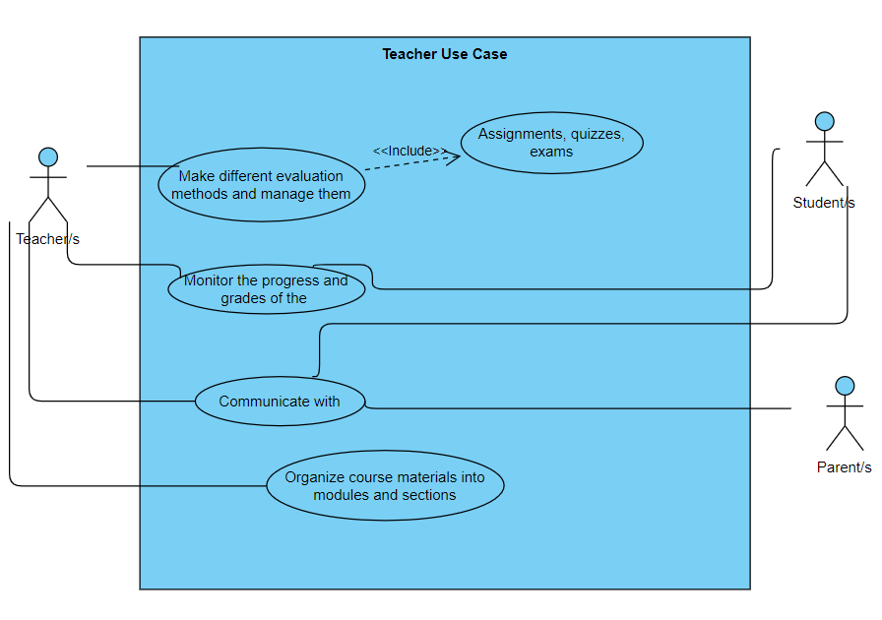

***Use Case 2(Student Use Case)***

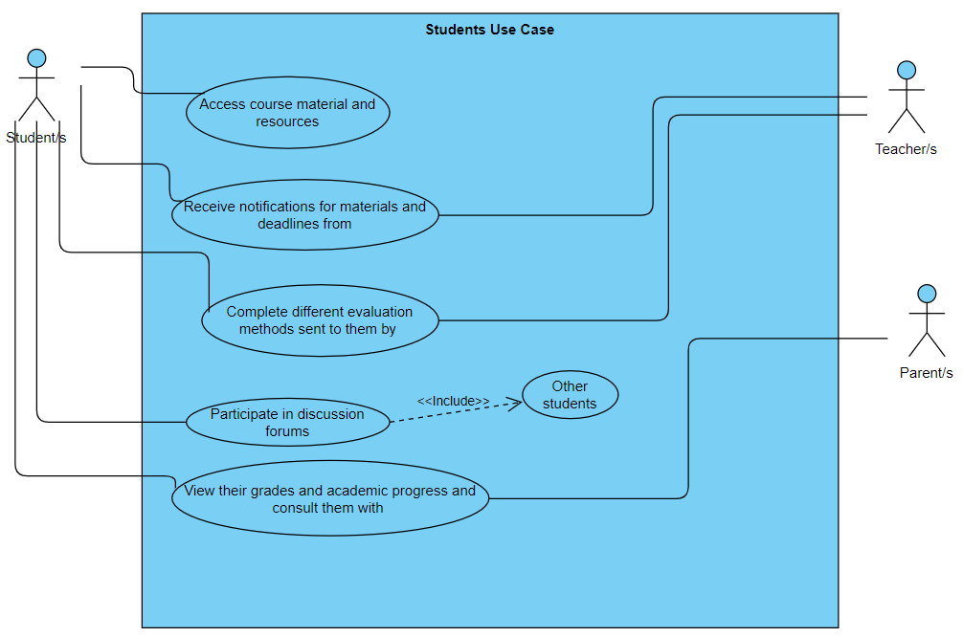

***Use Case 3 (Parent Use Case)***

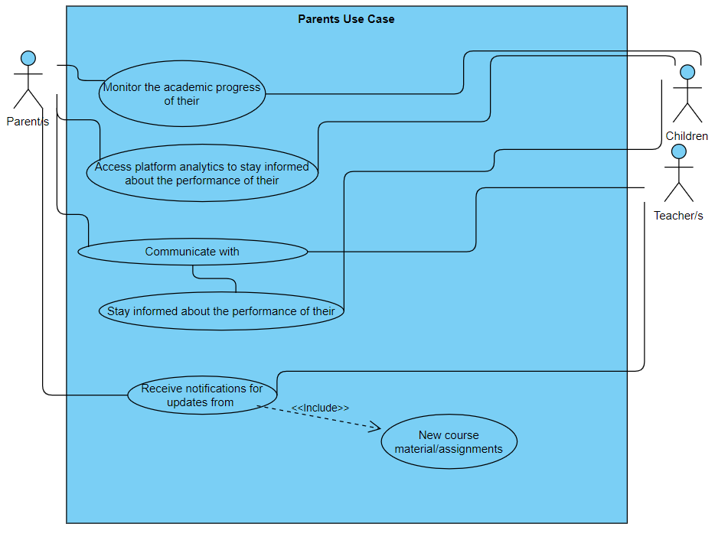

***Use Case 4 (All combined into one)***

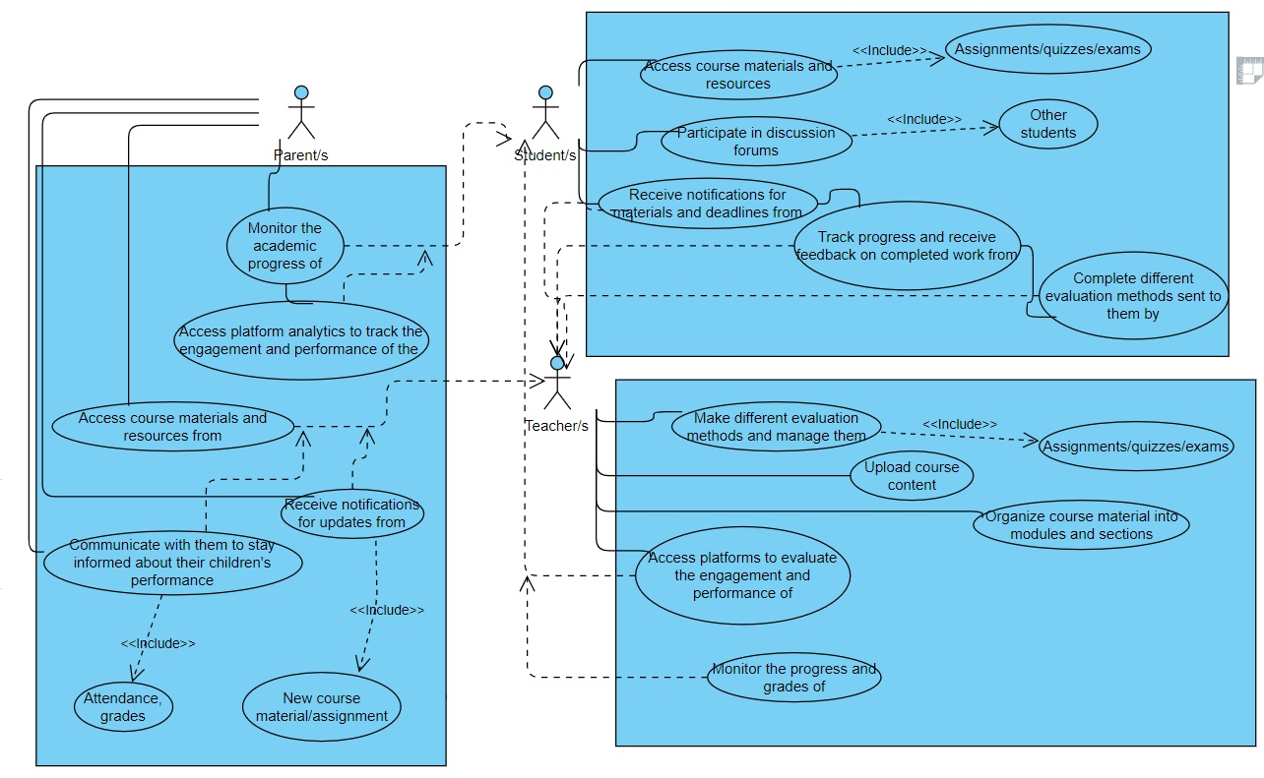

## 

## Use Cases Extended

| **Use Case (UC_1.1):** | Log In |
| --- | --- |
| Scope: | Teaching Platform App |
| Level: | User level |
| Intention Context: | The teacher/s need to log in to the application and then use it. |
| Minimum Guarantees: | Teacher enters login data but cannot log in. |
| Success Guarantees: | The teacher logs in successfully after entering data |
| Primary Actor: | Teacher |
| Stakeholder’s Interest: | To have teachers who know and use the application for the necessary educational services. |
| Precondition: | The application must be downloaded first before teachers log in to it. |

| **Use Case (UC_1.2):** | Making different evaluation methods and managing them |
| --- | --- |
| Scope: | Teaching Platform App |
| Level: | User level |
| Intention Context: | The teacher prepares different evaluation methods (assignments/quizzes/exams) and manages those by giving them to students or not by also looking at the difficulties students may have regarding a subject |
| Minimum Guarantees: | Teachers do not make an effort to use the platform to share the assignments there to students at all. |
| Success Guarantees: | The teachers share assignments daily/weekly in a respectable quantity for the students. |
| Primary Actor: | Teacher |
| Stakeholder’s Interest: | To have teachers who know and use the application in that that they should be able to send the students the assignments or other evaluation methods. |
| Precondition: | The platform needs to work correctly so the assignments are sent on time and without internet defects. |

| **Use Case (UC_1.3):** | Organizing course material into modules and sections |
| --- | --- |
| Scope: | Teaching Platform App |
| Level: | User level |
| Intention Context: | The teacher arranges everything he/she sends into modules and sections so that the student finds it easier to comprehend the material. |
| Minimum Guarantees: | Teachers are disorganized in their work and this leads to students not being able to comprehend the material properly. |
| Success Guarantees: | The teachers have such a level of organization in the work they do that the materials sent by them can be read and comprehended effortlessly. |
| Primary Actor: | Teacher |
| Stakeholder’s Interest: | To have teachers who know how to structure their work so that the materials they send are visually appalling as well. |
| Precondition: | The platform needs to work correctly so the teachers send the materials in a structured way after preparing them. |

| **Use Case (UC_1.4):** | Monitoring the progress and grades of the students |
| --- | --- |
| Scope: | Teaching Platform App |
| Level: | User level |
| Intention Context: | The teacher assesses the students constantly. In this way he/she checks what the students’ difficulties are and gives them feedback to improve. |
| Minimum Guarantees: | Teachers do not evaluate the performance of their students at all. |
| Success Guarantees: | The teacher evaluate the performance of their students frequently and helps them to correct their learning gaps. |
| Primary Actor: | Teacher |
| Stakeholder’s Interest: | To have teachers who know how to assess their students online. |
| Precondition: | The platform needs to work correctly so the teachers are able to assess the oral/written work of their students online as well. |

| **Use Case (UC_2.1):** | Log In |
| --- | --- |
| Scope: | Teaching Platform App |
| Level: | User level |
| Intention Context: | The student needs to log in to the application and then use it. |
| Minimum Guarantees: | The student enters login data but cannot log in. |
| Success Guarantees: | The user logs in successfully after entering data |
| Primary Actor: | Student |
| Stakeholder’s Interest: | To have students who know and use the application for the necessary educational services. |
| Precondition: | The application must be downloaded first before students log in to it. |

| **Use Case (UC_2.2):** | Accessing course materials and resources |
| --- | --- |
| Scope: | Teaching Platform App |
| Level: | User level |
| Intention Context: | The student needs to log in to the application and then use it. |
| Minimum Guarantees: | The students cannot see materials and resources sent to them at all because the application is not functionable. |
| Success Guarantees: | The students have access to their corresponding materials and resources effortlessly, without spending too much time on them. |
| Primary Actor: | Student |
| Stakeholder’s Interest: | To have students who are able to view their materials and resources sent in a platform like Google Classroom. |
| Precondition: | The application should have a strong internet connection for that, or else the access will fail. |

| **Use Case (UC_2.3):** | Receiving notifications for materials and deadlines |
| --- | --- |
| Scope: | Teaching Platform App |
| Level: | User level |
| Intention Context: | The student receives information about the materials/deadlines that are sent to him in the classroom’s platform. |
| Minimum Guarantees: | The student does not receive any notifications for materials and/or deadlines at all. |
| Success Guarantees: | The student receives these notifications daily and in this way he/she is kept in touch with what happens in a classroom environment |
| Primary Actor: | Student |
| Stakeholder’s Interest: | To have students who are able to receive notifications about what their teacher is doing in the classroom. |
| Precondition: | The application should have a strong internet connection or else the students will fail to be informed. |

| **Use Case (UC_3.1):** | Log In |
| --- | --- |
| Scope: | Teaching Platform App |
| Level: | User level |
| Intention Context: | The parent needs to log in to the application and then use it. |
| Minimum Guarantees: | The parents enter login data but cannot log in. |
| Success Guarantees: | The parent logs in successfully after entering data |
| Primary Actor: | Parent |
| Stakeholder’s Interest: | To have parents who know and use the application for the necessary educational services. |
| Precondition: | The application must be downloaded first before parents log in to it. |

| **Use Case (UC_3.2):** | Monitoring the academic progress of parents’ children |
| --- | --- |
| Scope: | Teaching Platform App |
| Level: | User level |
| Intention Context: | The parent |
| Minimum Guarantees: | The parent does not control his/her child at all. |
| Success Guarantees: | The parent checks the progress of his/her child constantly and does what he/she can so that the child gets the best from his/her educational institution. |
| Primary Actor: | Parent |
| Stakeholder’s Interest: | To have parents who are responsible for what their children are doing in classroom and taking precautions if they see that their children are not progressing. |
| Precondition: | The platform must be fully functionable or else the parents will not be able to view their children’s grades at all |

| **Use Case (UC_3.3):** | Parents communicate with teachers/students |
| --- | --- |
| Scope: | Teaching Platform App |
| Level: | User level |
| Intention Context: | The parents (but not only) find a communication way online with the aid of the platform and exchange information with each other there. |
| Minimum Guarantees: | The communication between parents, teachers and students is almost zero. |
| Success Guarantees: | The parents, teachers, and students communicate easily in this platform, so they are able to exchange information properly between each other. |
| Primary Actor: | Parent |
| Stakeholder’s Interest: | To have parents who are able to communicate on an online platform. Communication is essential not only in a classroom environment, but also in other areas of life. |
| Precondition: | The platform must be fully functionable or else the parents will not be able to communicate with their children or teachers at all. |

## BPMN

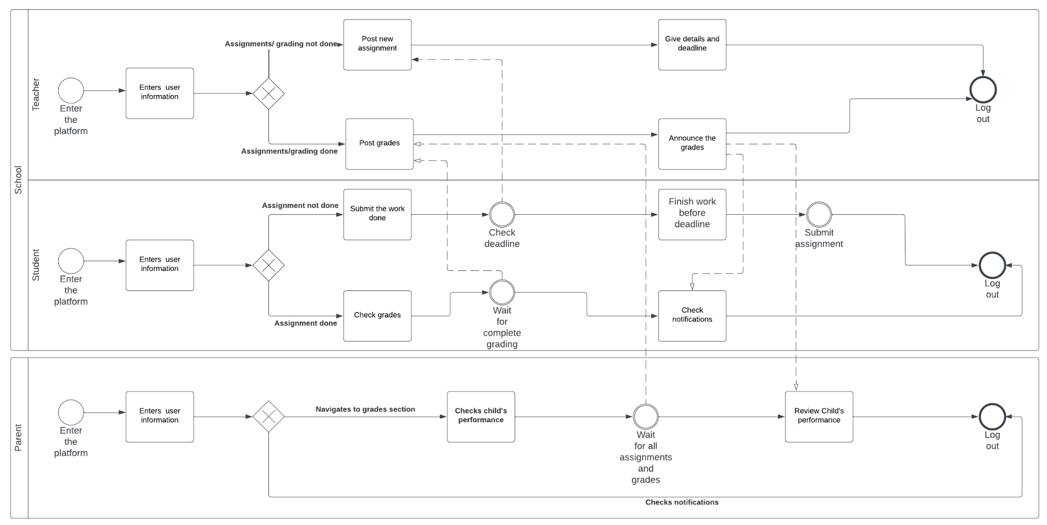

## 

## Data Flow Diagrams

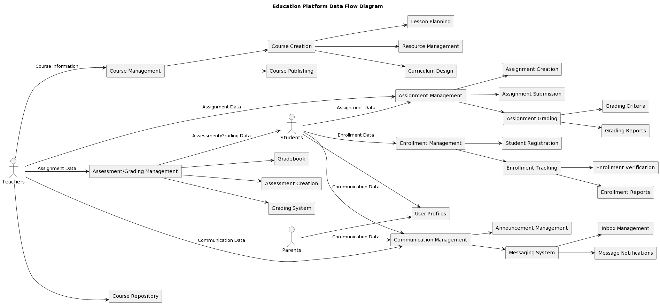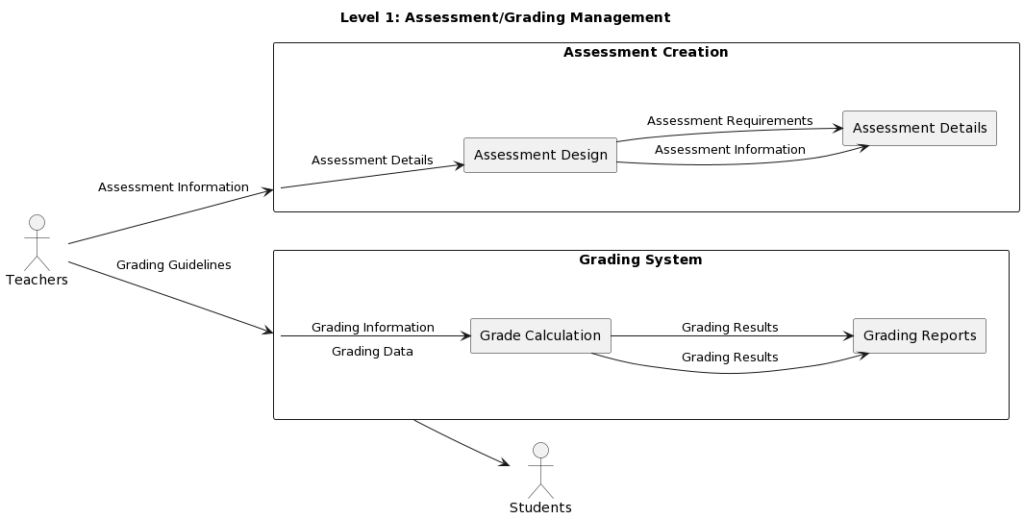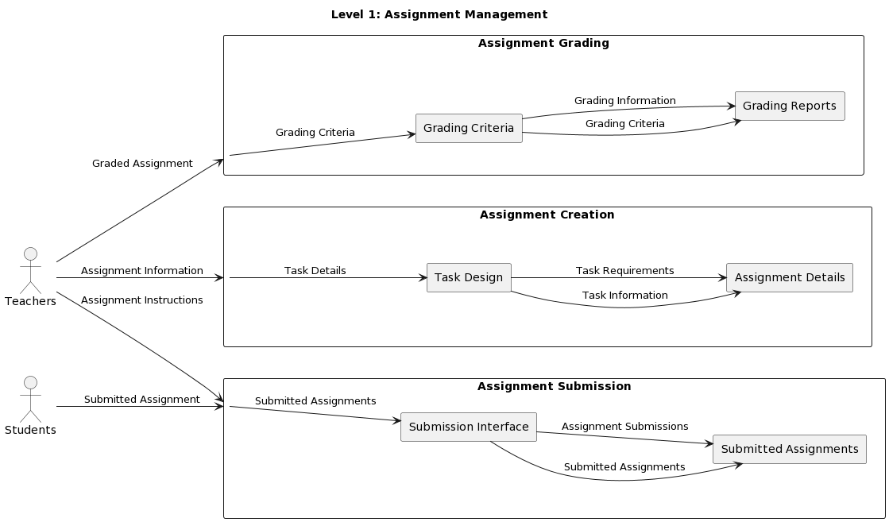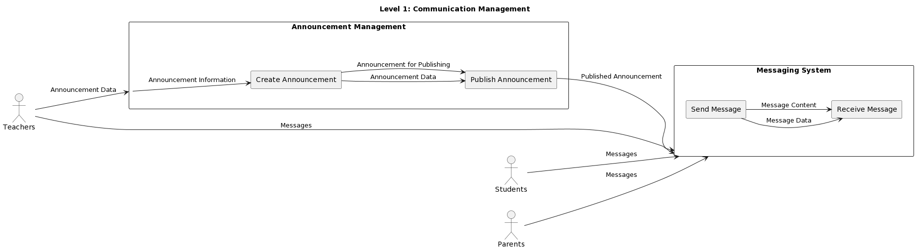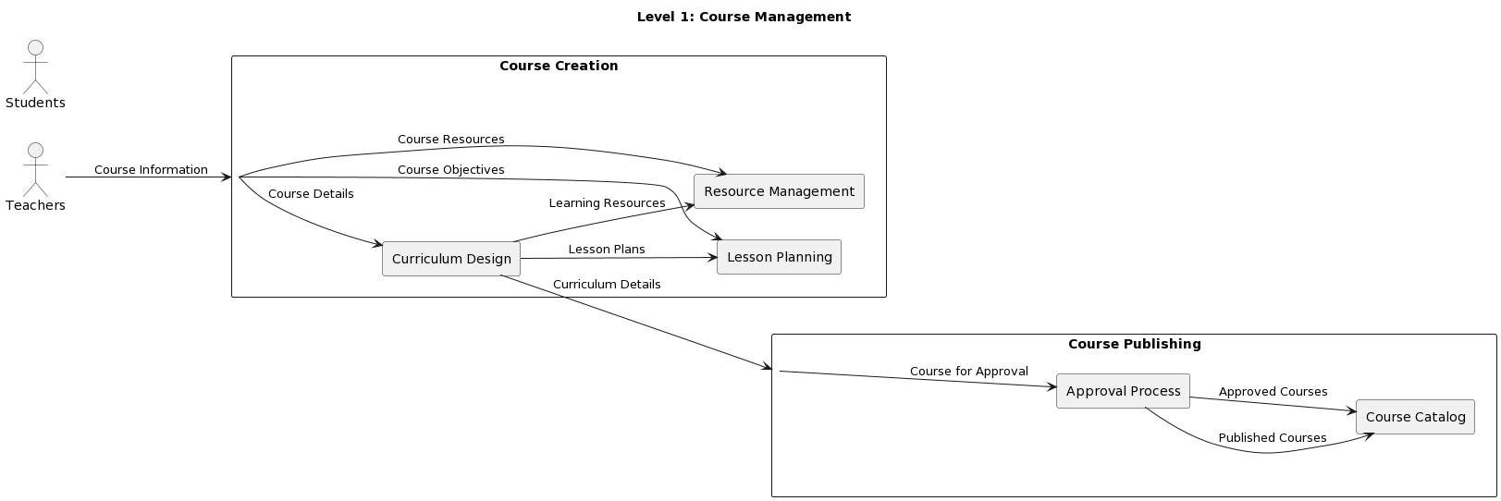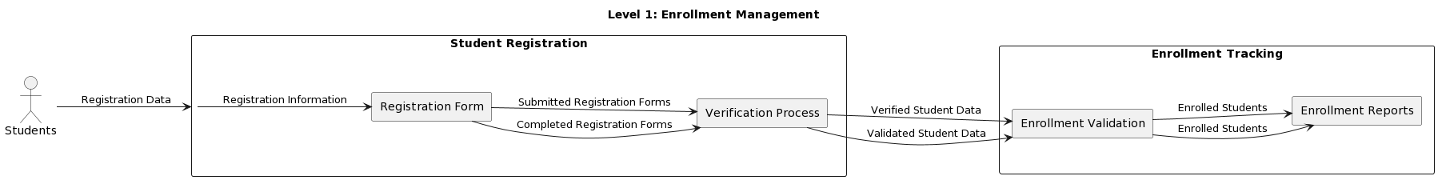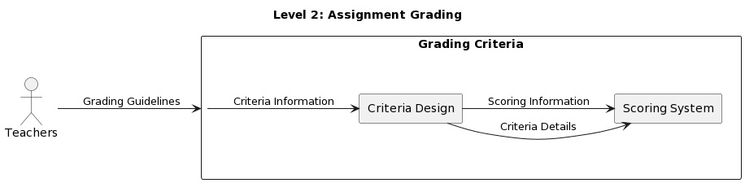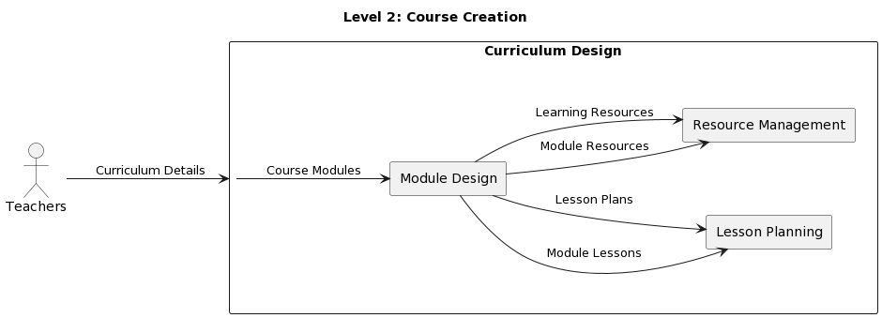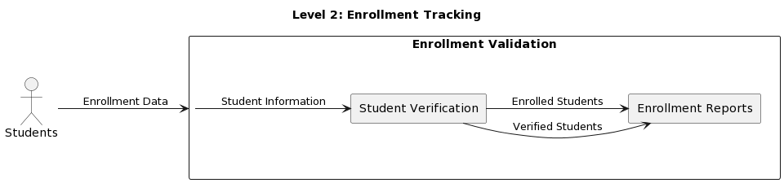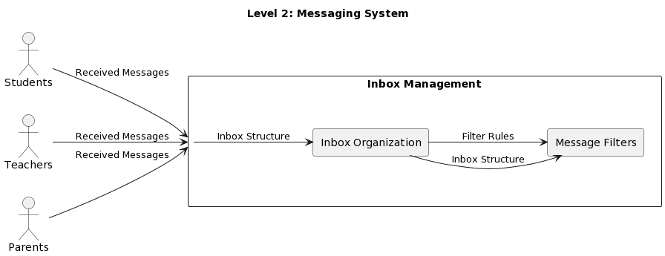

## Entity-Relationship Diagram

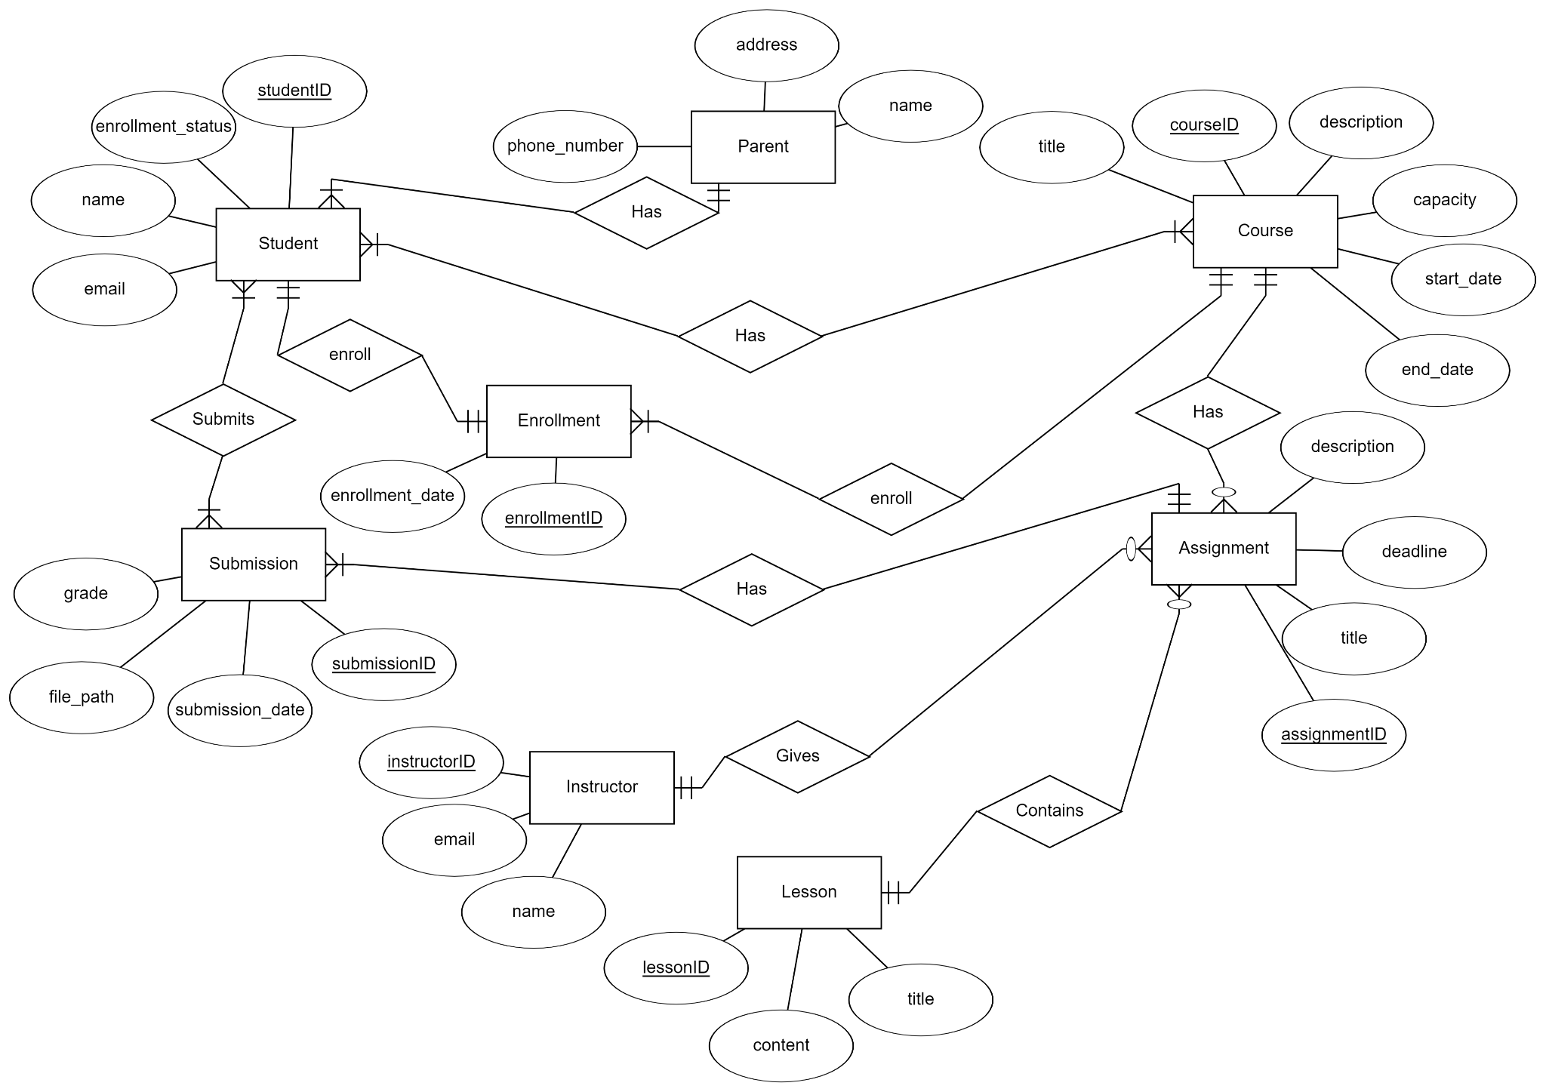

## Activity Diagrams

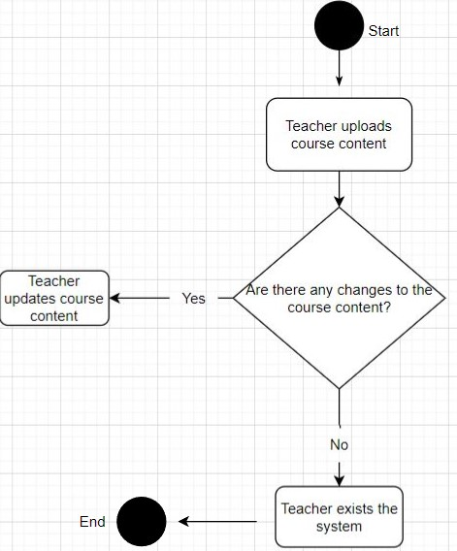

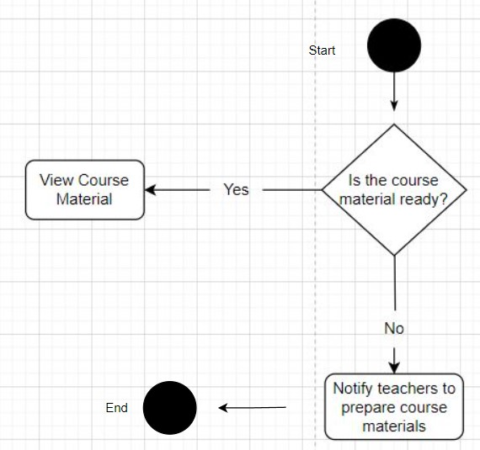

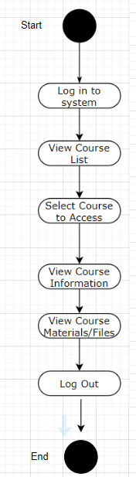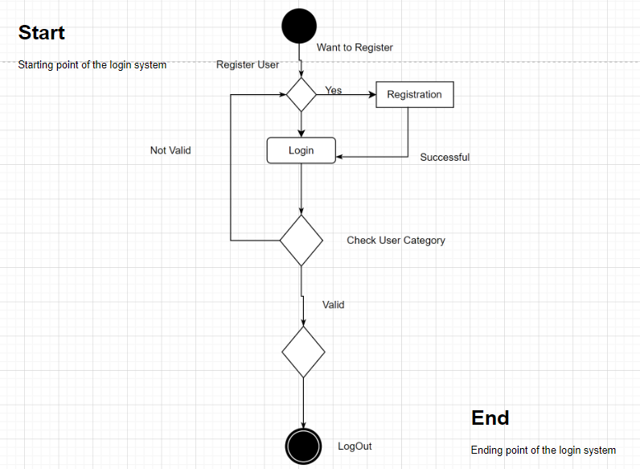

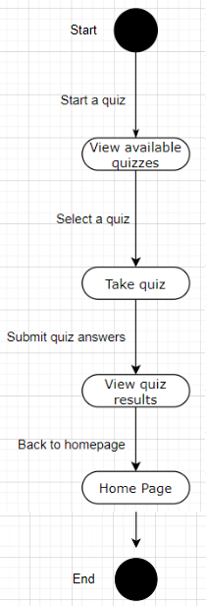

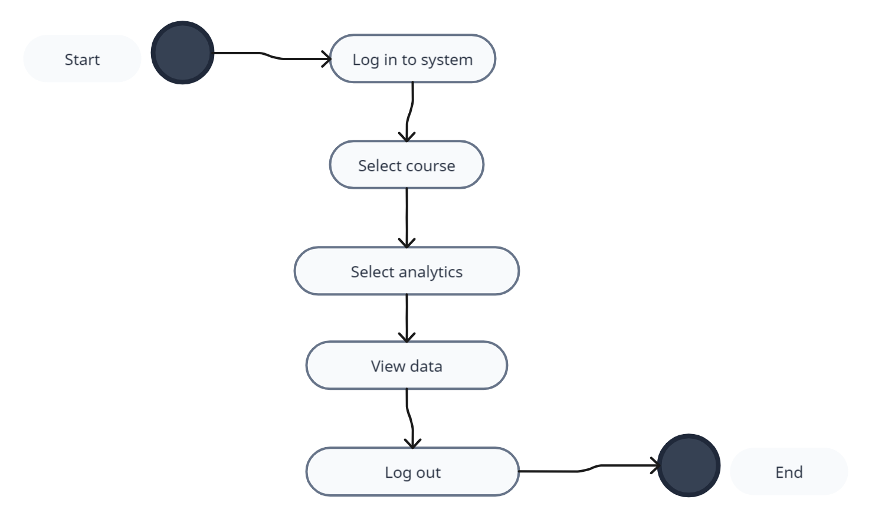

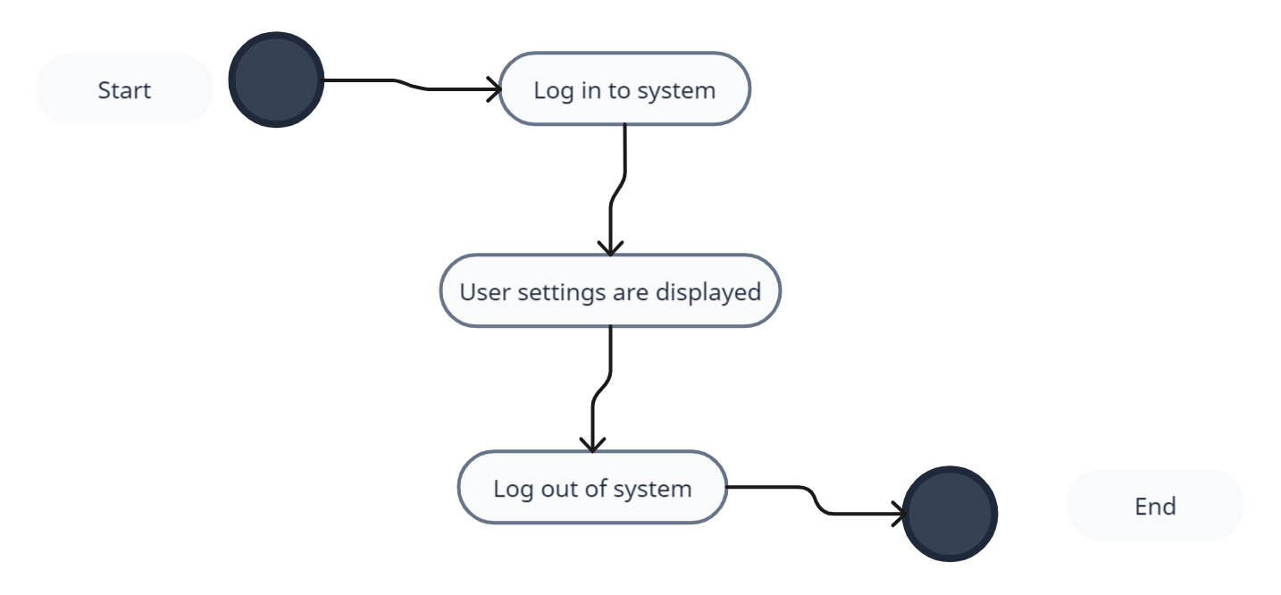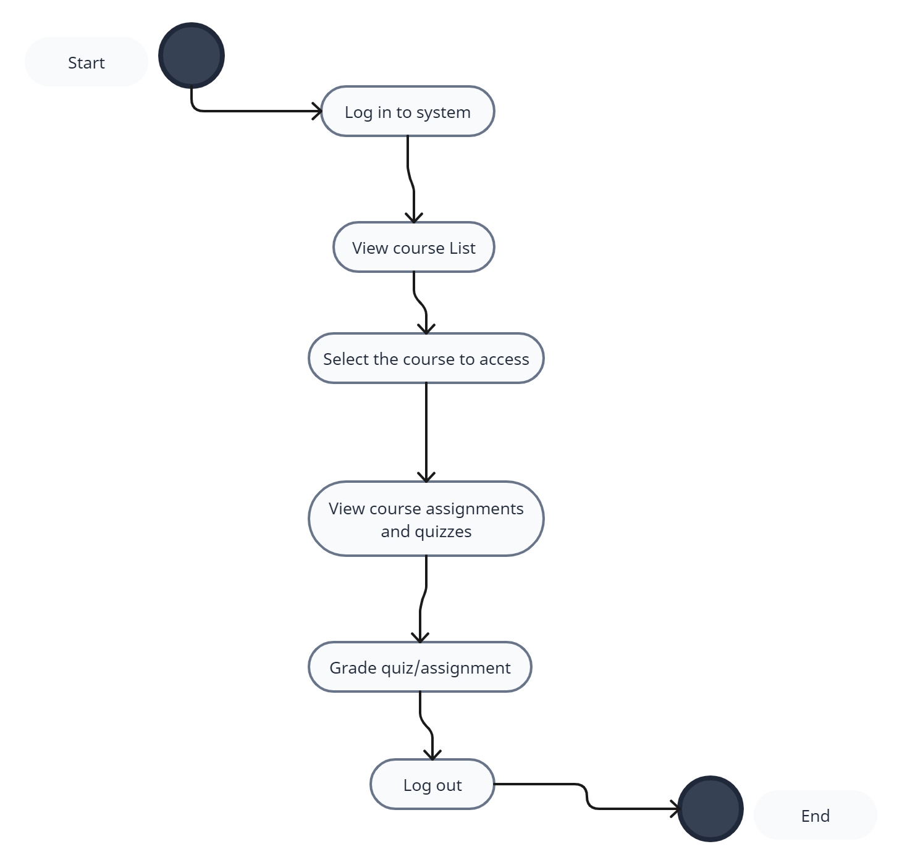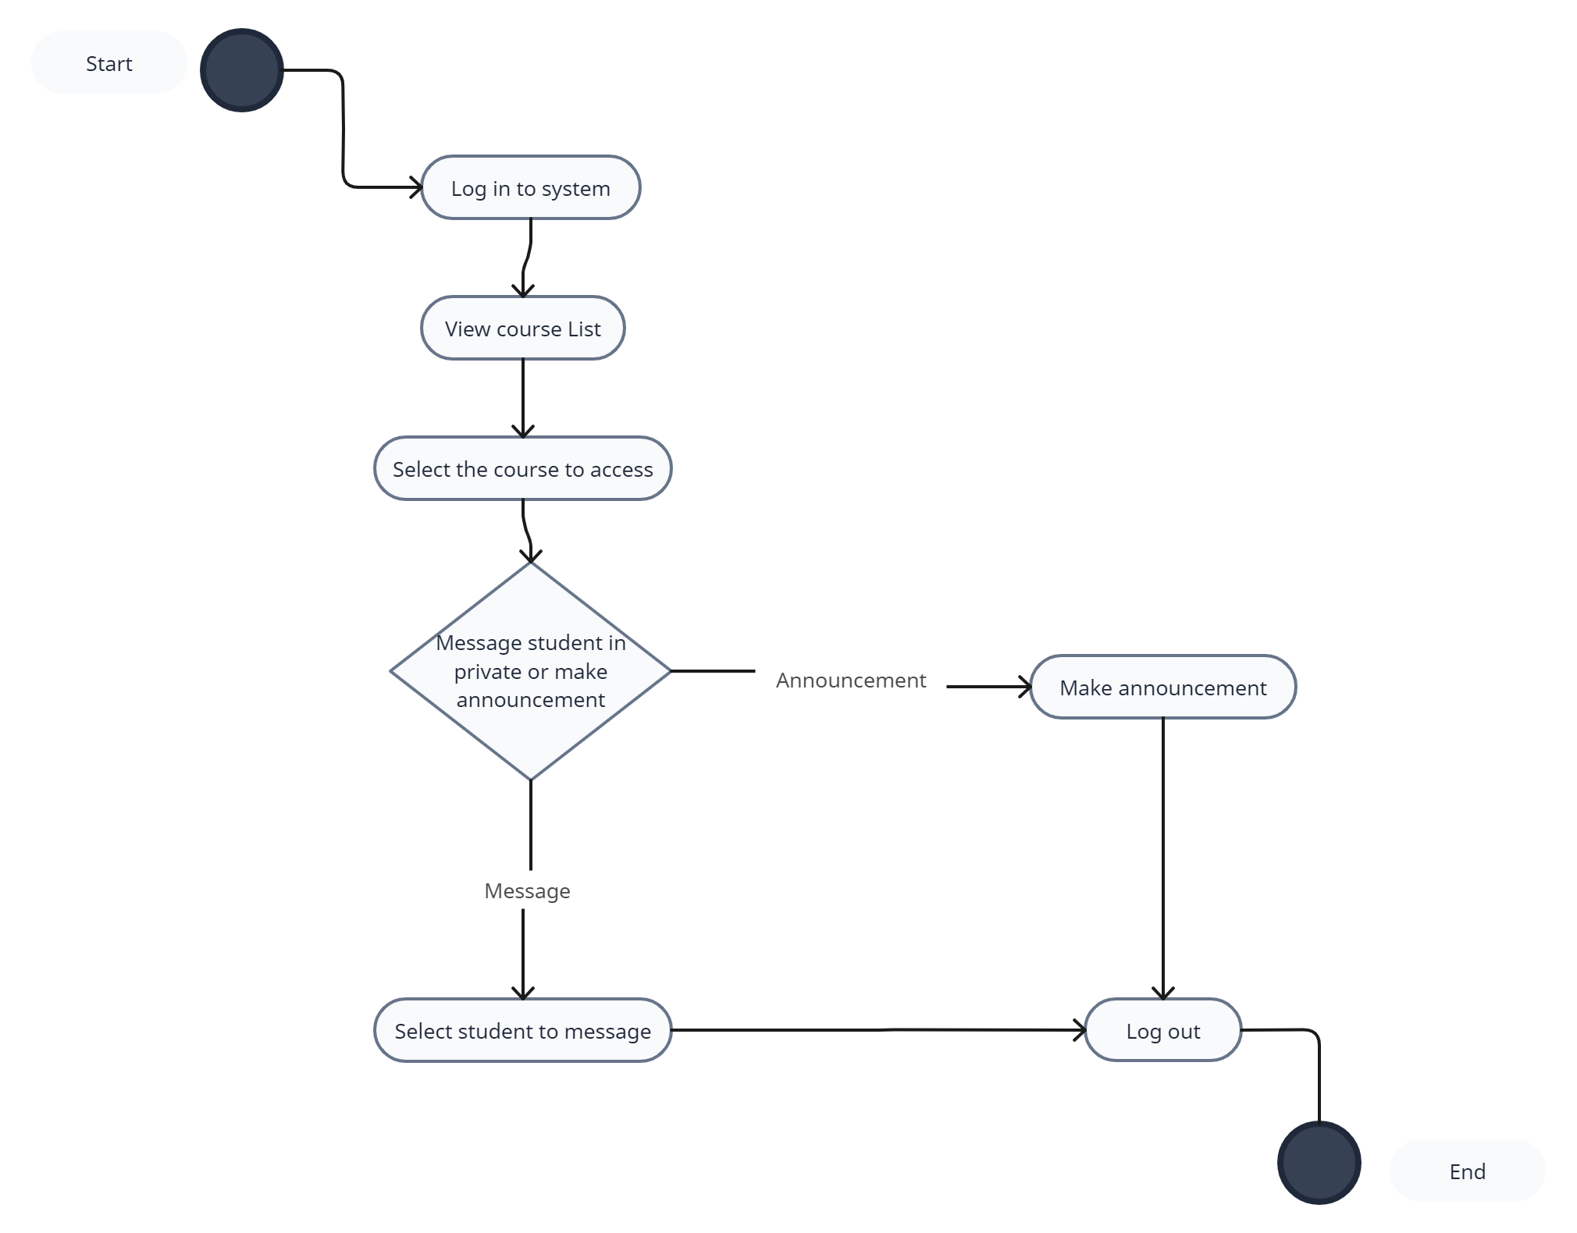

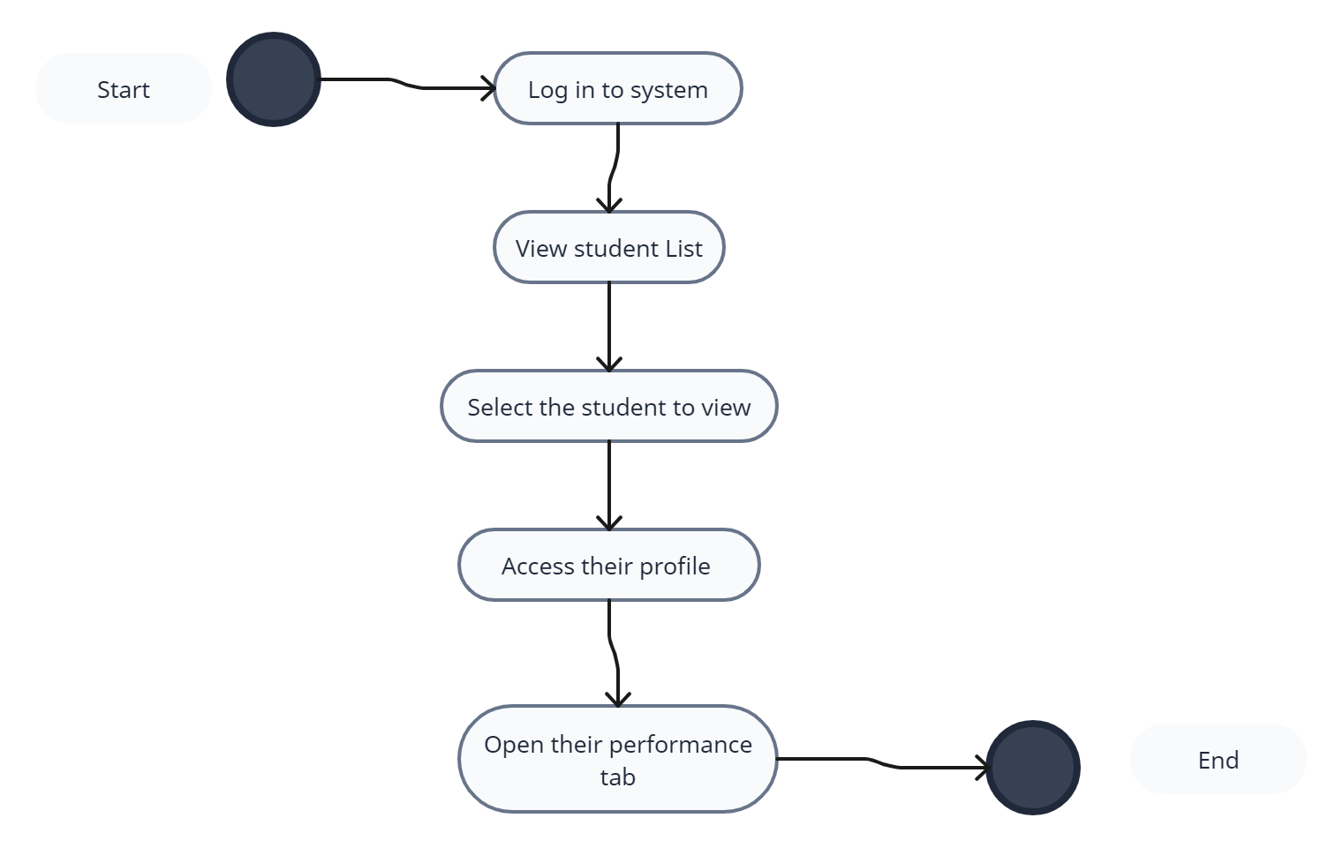

## 

## Sequence Diagram

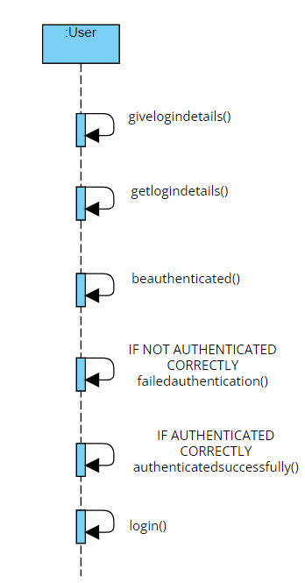

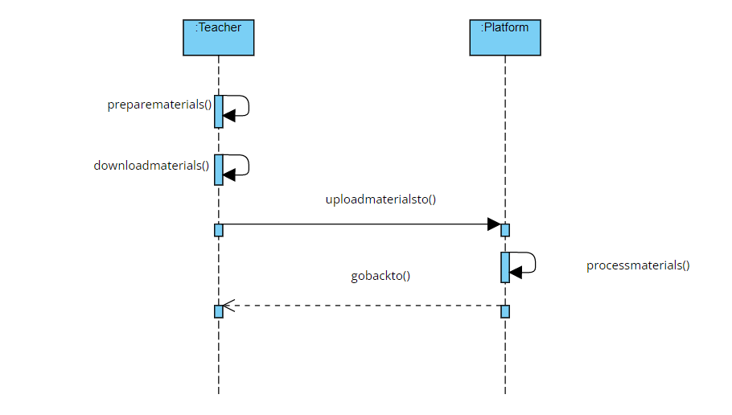

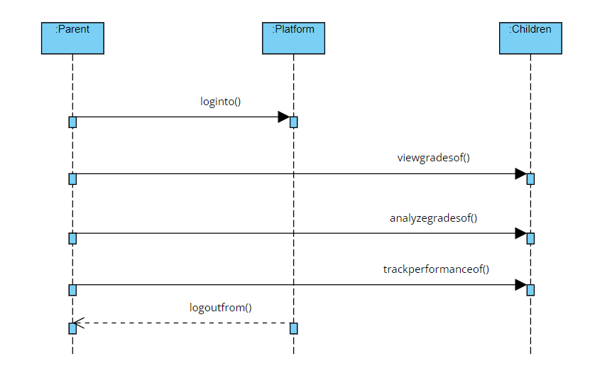

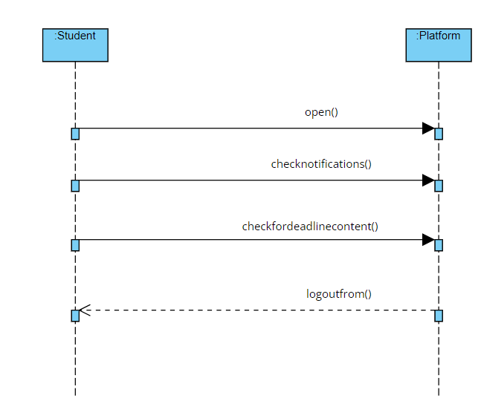

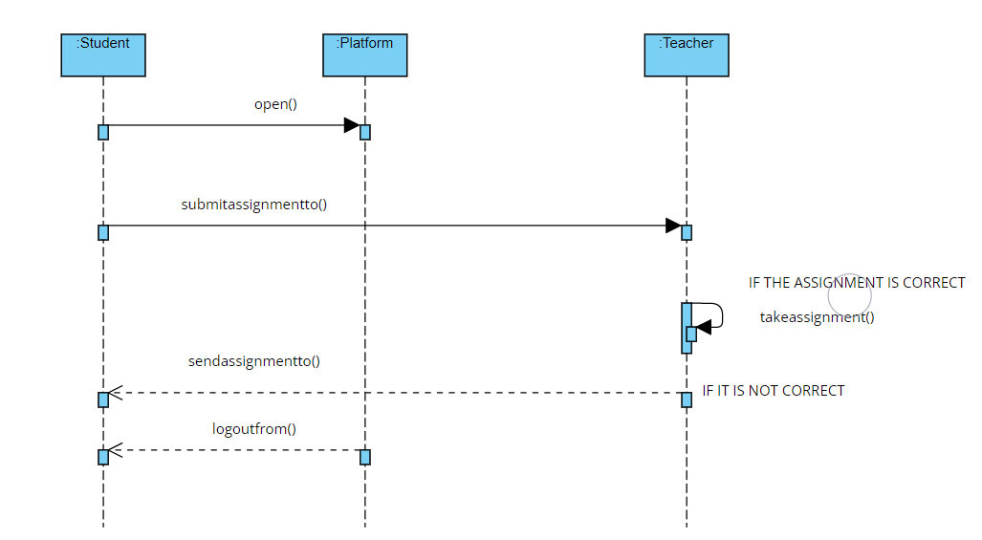

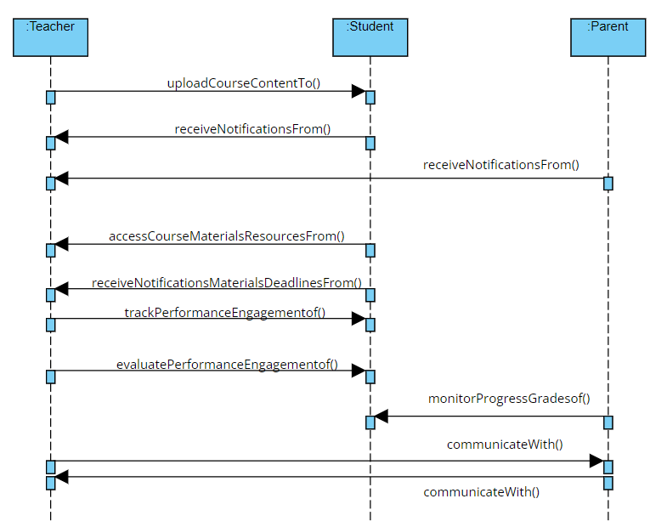

## State Diagrams

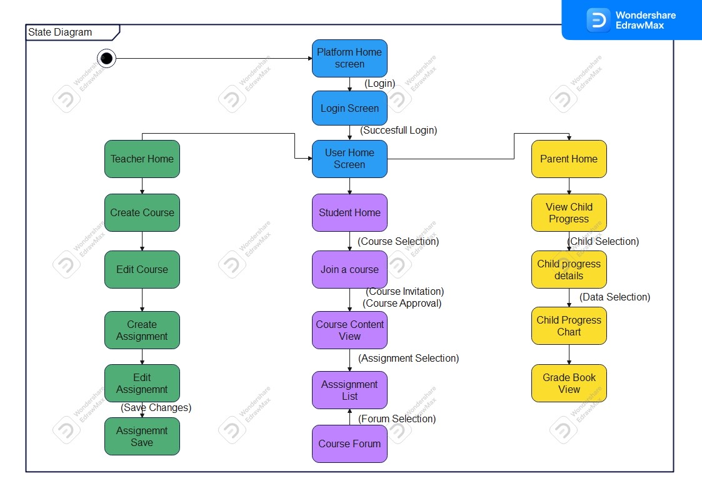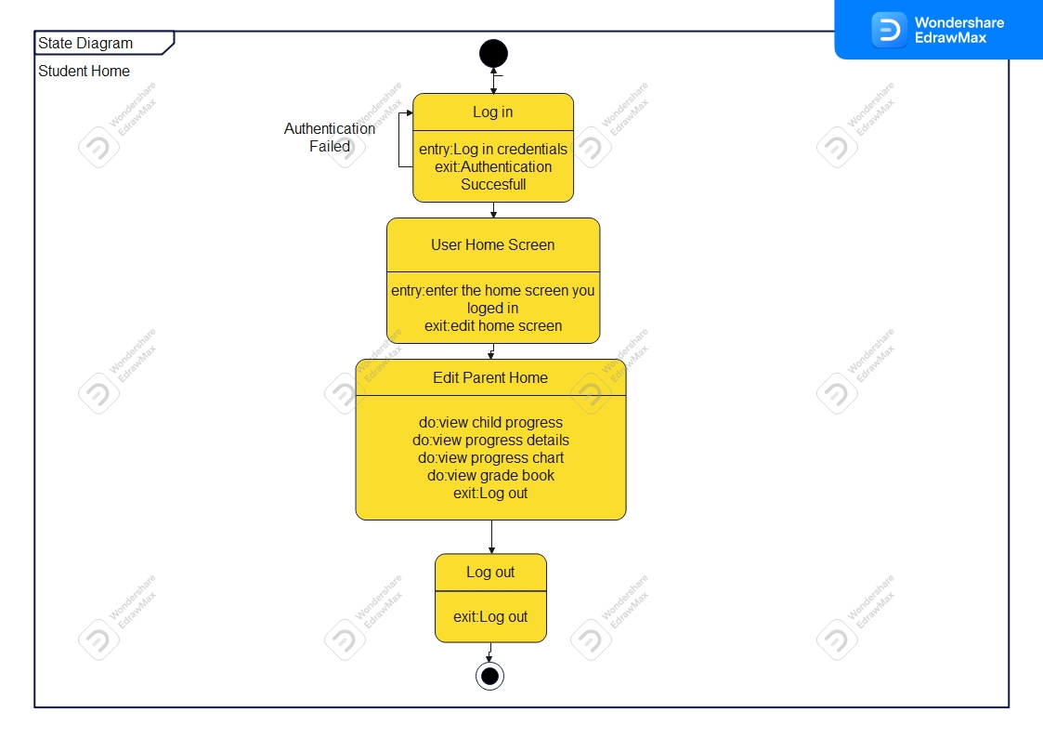

Parent Action State Diagrams:

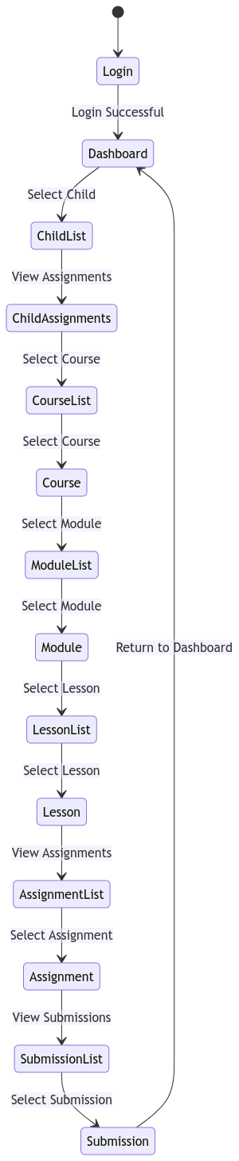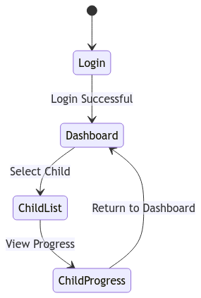

Student Action State Diagrams:

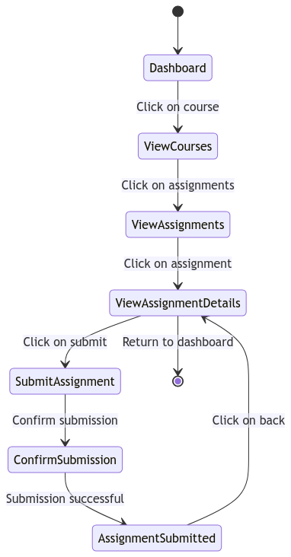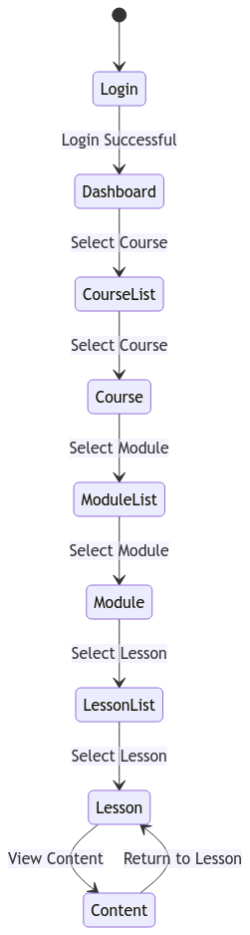

Teacher Action State Diagrams:

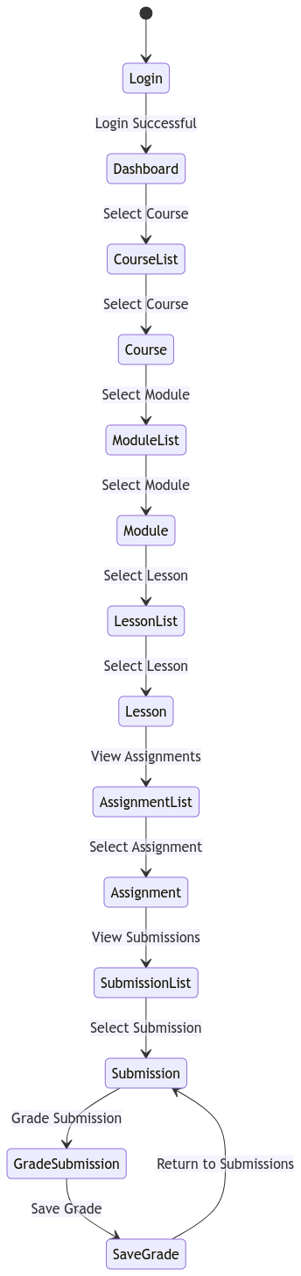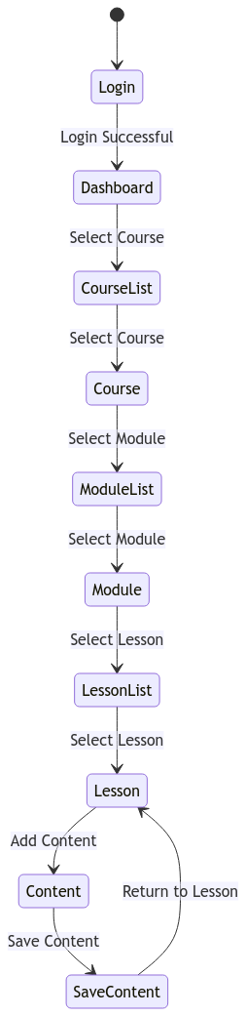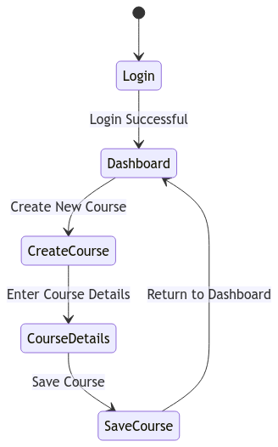

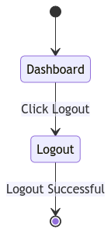

## Class Diagram

